Senior English name: ________
P. Dobie – Point Grey Secondary
Literature Analysis
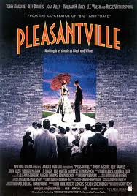
Short Essay (Character exploration/use of colour as a motif): Pleasantville

Essay outline
- Introductory lines about the complexity of the human condition – the theme of the film. (comment about ‘change’ and our ability to ‘change’.)
- 2-3 sentences where you reword the question to state exactly what you will explore in this essay (i.e: the character and how colour is used as a motif to add a thematic layer to the narrative. (THESIS STATEMENT)
- This paragraph introduces us to the character as first revealed in the first segment of the film & ties it into the director’s use of colour (or the absence of colour). Explain how we first see the character.
- Choose one event which reveals the beginning of dynamic change (or how it sets the character up for potential change.) Again, remember to tie the importance of colour/absence of colour into this explanation.
- Analyse the most pivotal scene for this character. What do we learn about the character and how might it relate to other characters in the film (possible foils). How has the character become ‘dynamic’? How does it relate to the theme of the film? How has the director again used colour, camera angle, light to emphasize the meaning. What was the catalyst that finally caused a change in this character?
- Explain the final resolution of that character. Describe the importance of the change they have gone through and finally, circle back to your opening two sentences where you wrote about the complexity of the human condition.
Note:
Conventions:
Never use personal pronouns (I, me, my, mine)
Refer the full name of the director: Gary Ross and after that only refer to Ross (never his first name).
Also, introduce the fact that it is a film you are exploring (note a short story or poem….) & the title of the movie.
You may refer to ‘the reader or the viewer’ or ‘we’ or ‘one’.

